

AWS re/Start Certification Exam Scheduling and Voucher Access Instructions:

*Updated April 10, 2025*

# Introduction

Upon successful completion of the AWS re/Start program and after receiving an AWS re/Start digital badge, each graduate of AWS re/Start may receive up to one 100% discounted Cloud Practitioner Certification voucher, upon the request of the AWS re/Start collaborating organization and subject to approval by AWS.

Note that only one 100% discounted certification exam code for each learner is provided by AWS re/Start (AWS re/Start does not provide vouchers for retakes).

This document outlines steps for AWS re/Start collaborating organizations to access the vouchers and support learners with scheduling the certification exams.

**Note:** Starting March 25, 2025, new vouchers will be distributed via the Pearson Vue platform.

**Note:** Xvoucher will no longer be available starting mid-April

* For any voucher codes previously allocated to learners in Xvoucher, those voucher codes will remain valid for the learner to use when scheduling the exam
* If you have any issues or questions, open a case with AWS re/Start Customer Support <https://support.aws.amazon.com/#/contacts/aws-restart>

# Validating the number of graduates for whom to request vouchers

On or before the last day of a cohort, the AWS re/Start collaborating organization (instructor and/or course coordinator with access to the Canvas class for the cohort) must access Canvas to confirm the total number of learners who have been validated as “graduated.” This is visible in Canvas gradebook which can be accessed by selecting “Grades” (or local language equivalent) on the left-hand menu.

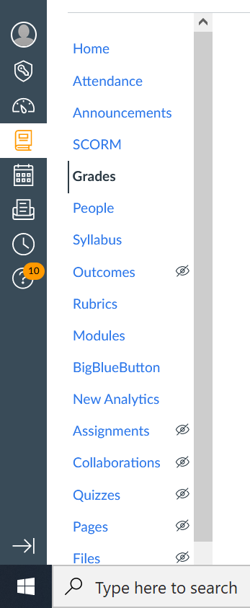

In Canvas gradebook, type in “Graduated” into the assignment bar to see a list of the learners who have been validated as graduated based on system requirements.

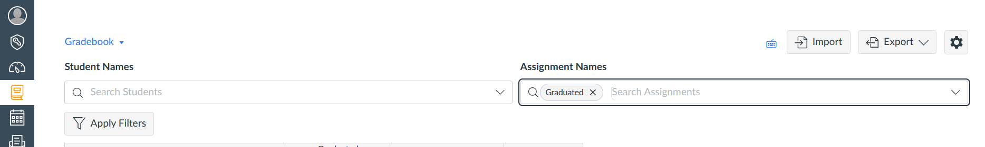

# Requesting vouchers for the graduates

After confirming the final number of graduates, the AWS re/Start collaborating organization should contact AWS re/Start Support using [this form](https://support.aws.amazon.com/#/contacts/aws-restart) to request vouchers. Include the following in your request:

* First and last name of person distributing vouchers:
* Email address of person distributing vouchers:
* Collaborating Organization Name:
* # of learners taking the exam (may not exceed number of validated graduates):
* Cohort ID:
* Date needed (must be at least one week from when request is submitted):

Within one week, you will receive a confirmation from AWS re/Start Support that the graduate numbers have been validated and vouchers have been distributed to the AWS re/Start collaborating organization’s Pearson Vue account. If your collaborating organization -and/or the person distributing the vouchers- does not yet have a Pearson Vue account, expect to receive an invitation from the Pearson Vue voucher platform. You may access the Pearson Vue platform for which to access vouchers through the steps outlined below.

# Accessing Pearson Vue for vouchers after they have been distributed by AWS re/Start Customer Support

**Step 1.** You will receive an email from support@pvstore.pearson.com with subject, “Admin access has been setup for you in My Product” and with a “reply to” email address of [mindhub@pearson.com](mailto:mindhub@pearson.com)

**Step 2.** Proceed to set up your account (new users must select “forgot password”). Note that your username is your email address.

**Step 3.** When you receive your vouchers, the subject is “New voucher available for distribution.” You will sign in with your username (email address).

**Step 4.** Log into Pearson Vue - <https://awsstore.pearsonvue.com//>

**Step 5.** Click on “My Account”

**Step 6.** Click on “My Product Manager”

**Step 7.** Click “Accept” if you accept (first time logging in only)

**Step 8.** Click on “Certification Vouchers”

**Step 9.** Click on “Bulk Assignment”

**Step 10.** Select “Upload Excel sheet” or “Type in Multiple Emails” to enter the email addresses of the graduates who you would like to receive the vouchers.

**Step 11:**

After you enter the graduate email addresses, each graduate will receive an email from Pearson Vue with their individually assigned voucher code. You can now monitor the graduates’ progress in scheduling their exams through your Pearson Vue account in the “My Product Manager” view.

# Walk-through for scheduling remote exams

Each graduate is responsible for booking their certification exam themselves, this cannot be managed on their behalf. The following is a guide for AWS re/Start collaborating organizations to support graduates in scheduling their exams.

**IMPORTANT TO SHARE WITH GRADUATES** – Ensure your identification information matches your government ID including name (First name, middle name and last name) to avoid being prevented from taking your exam on the day.

If you do NOT have an AWS Certification account

* Create an account with <https://www.aws.training/Certification> using the step-by-step guide below. Please also check the ***Additional*** ***Useful Information*** section at the end.

If you already have an AWS Certification account

* ***Skip to Step 7:***

**Step 1:** Go to <https://www.aws.training/Certification> and click on Sign-in

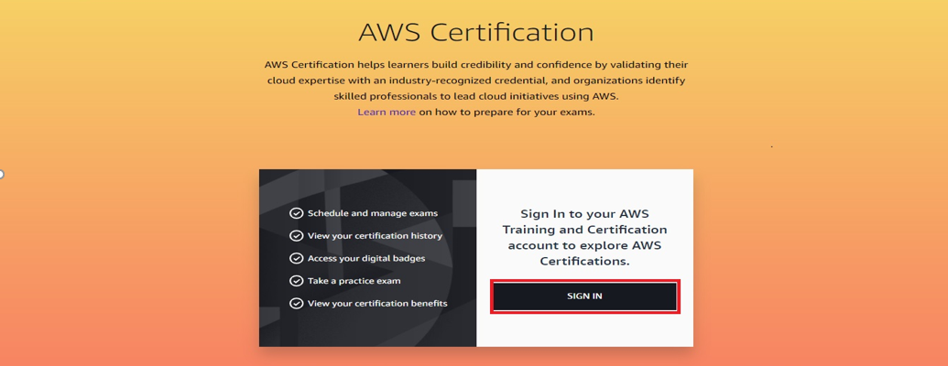

**Step 2:** Click ‘Sign in with a different option’

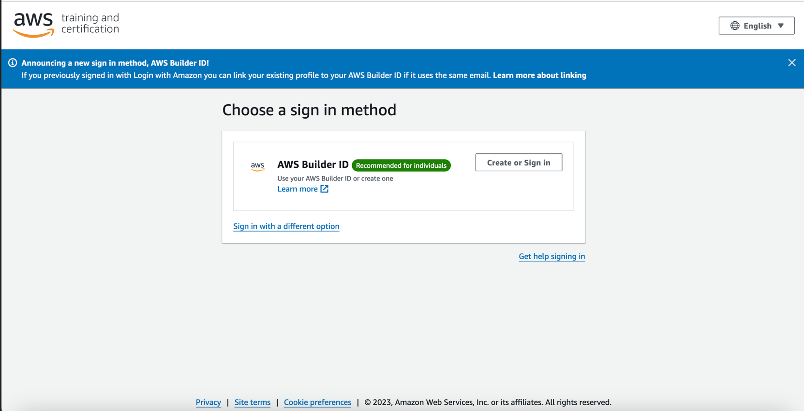

**Step 3:** Choose ‘Login with Amazon’

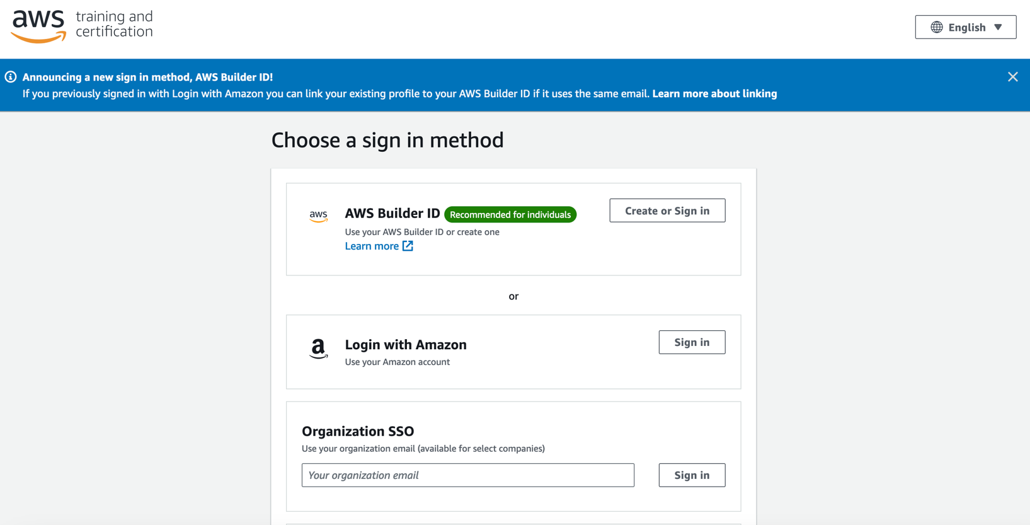

**Step 4:** Click ‘GO TO YOUR ACCOUNT’

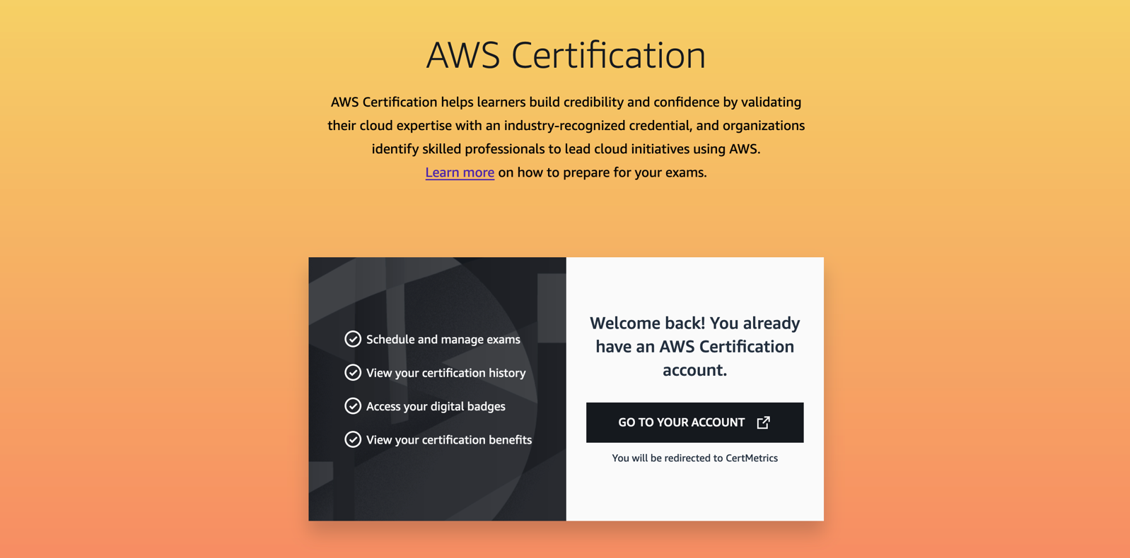

**Step 5:** Click on the “Create your Amazon Account” at the bottom as highlighted

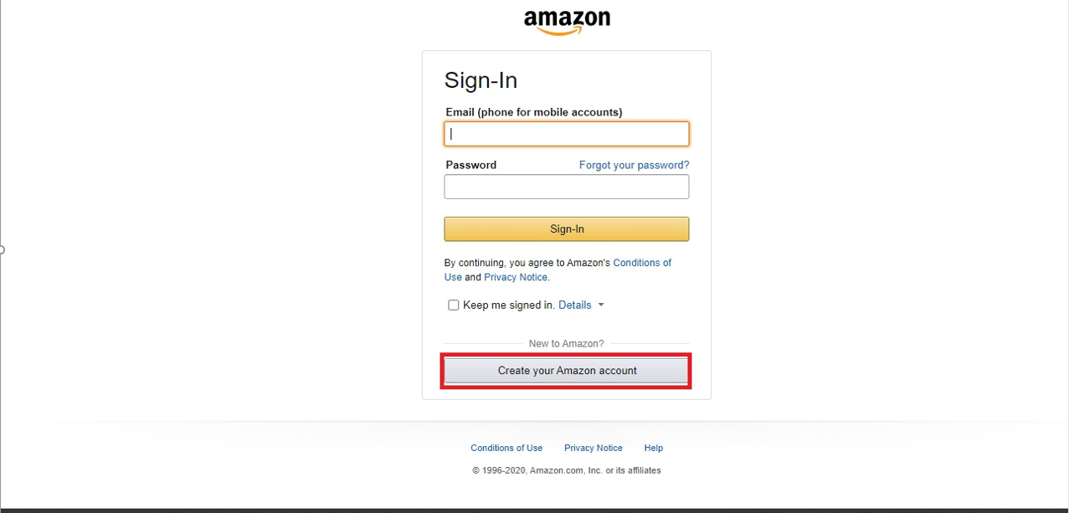

**Step 6:** Fill in **Your name**, **Email** and **Password** (both passwords ***must*** match) 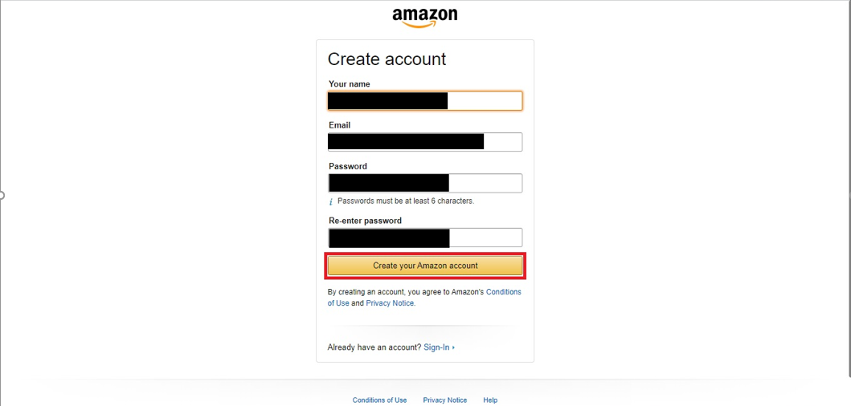

**Step 7:** Go to [www.aws.training/certification](http://www.aws.training/certification) and click ‘Sign-in’ as shown below:

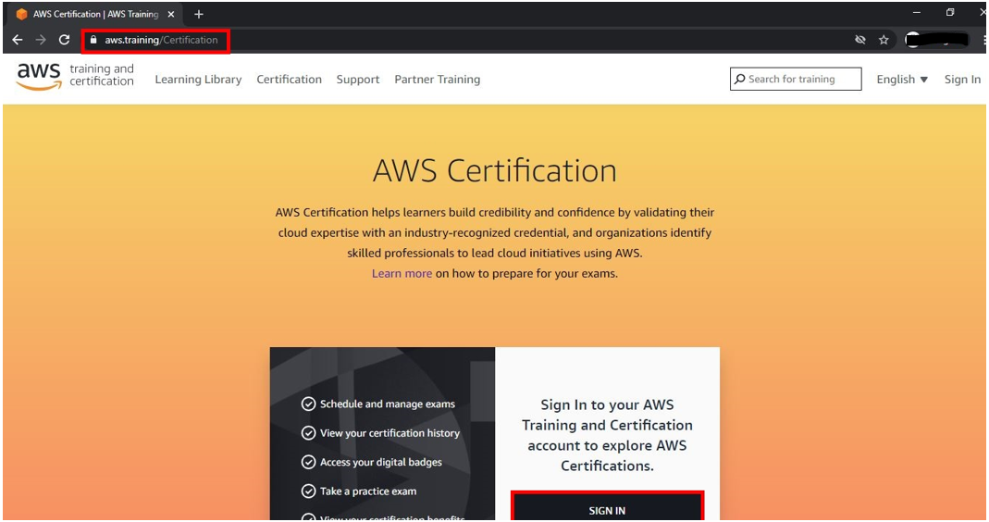

**Step 8:** Select “All regions” and click ‘Sign-in’ as highlighted below:

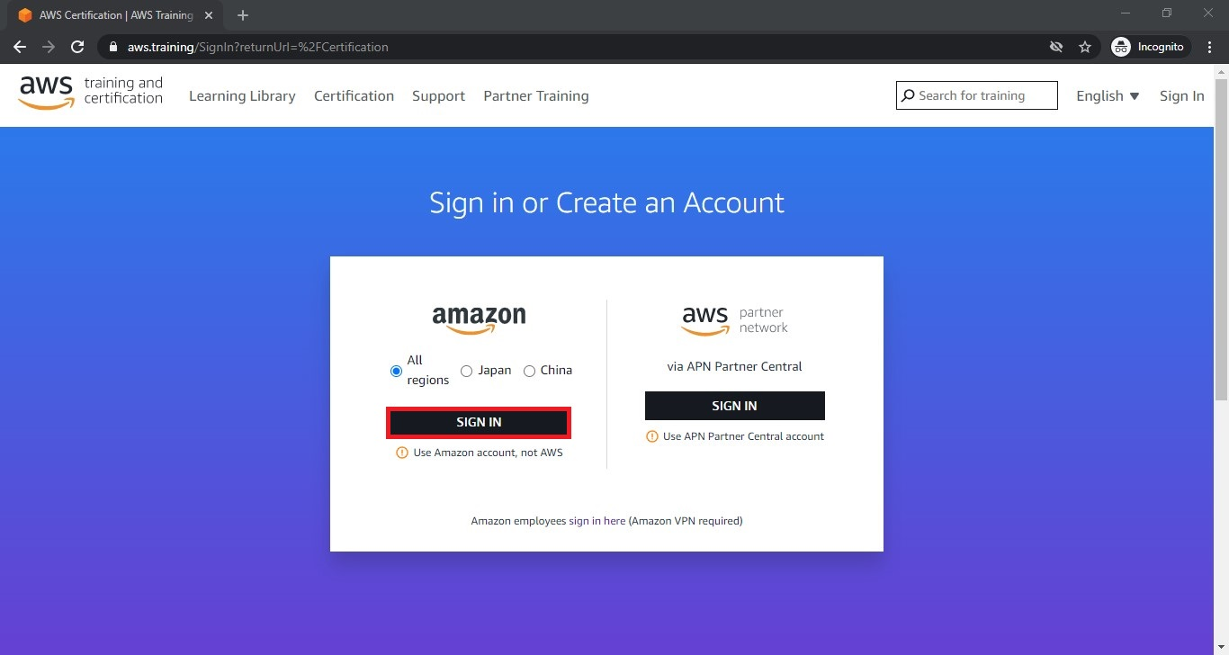

**Step 9:** ‘Sign-in’ with your email address and password

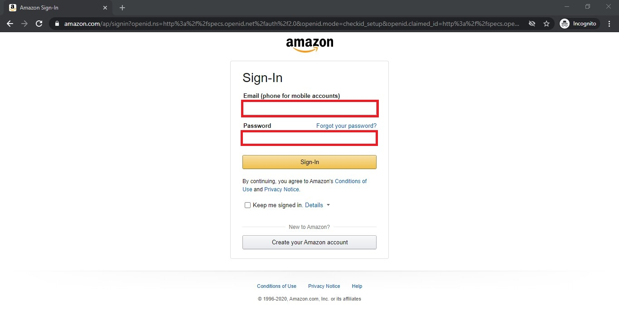

**Step 10:** Click on the yellow ‘Sign-in’ button

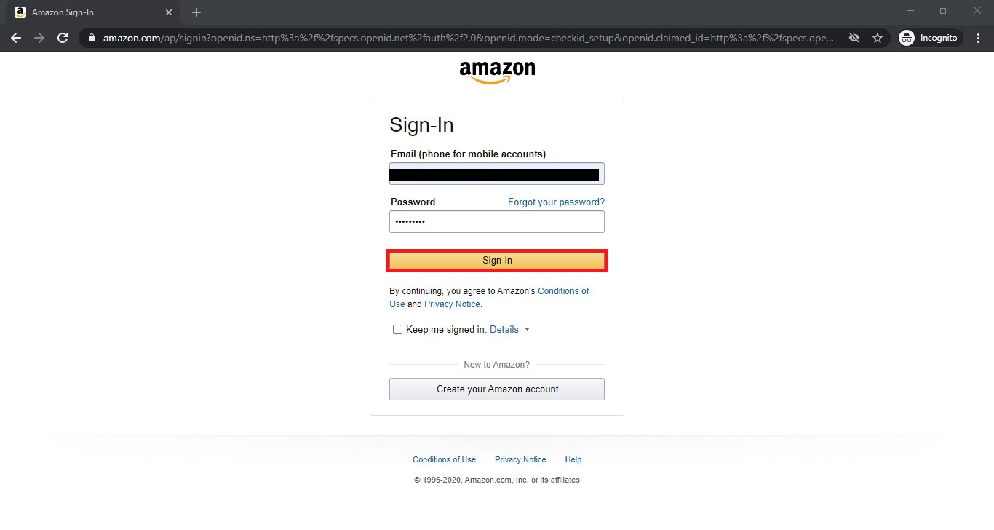

**Step 11:** Select “GO TO YOUR ACCOUNT” as highlighted below

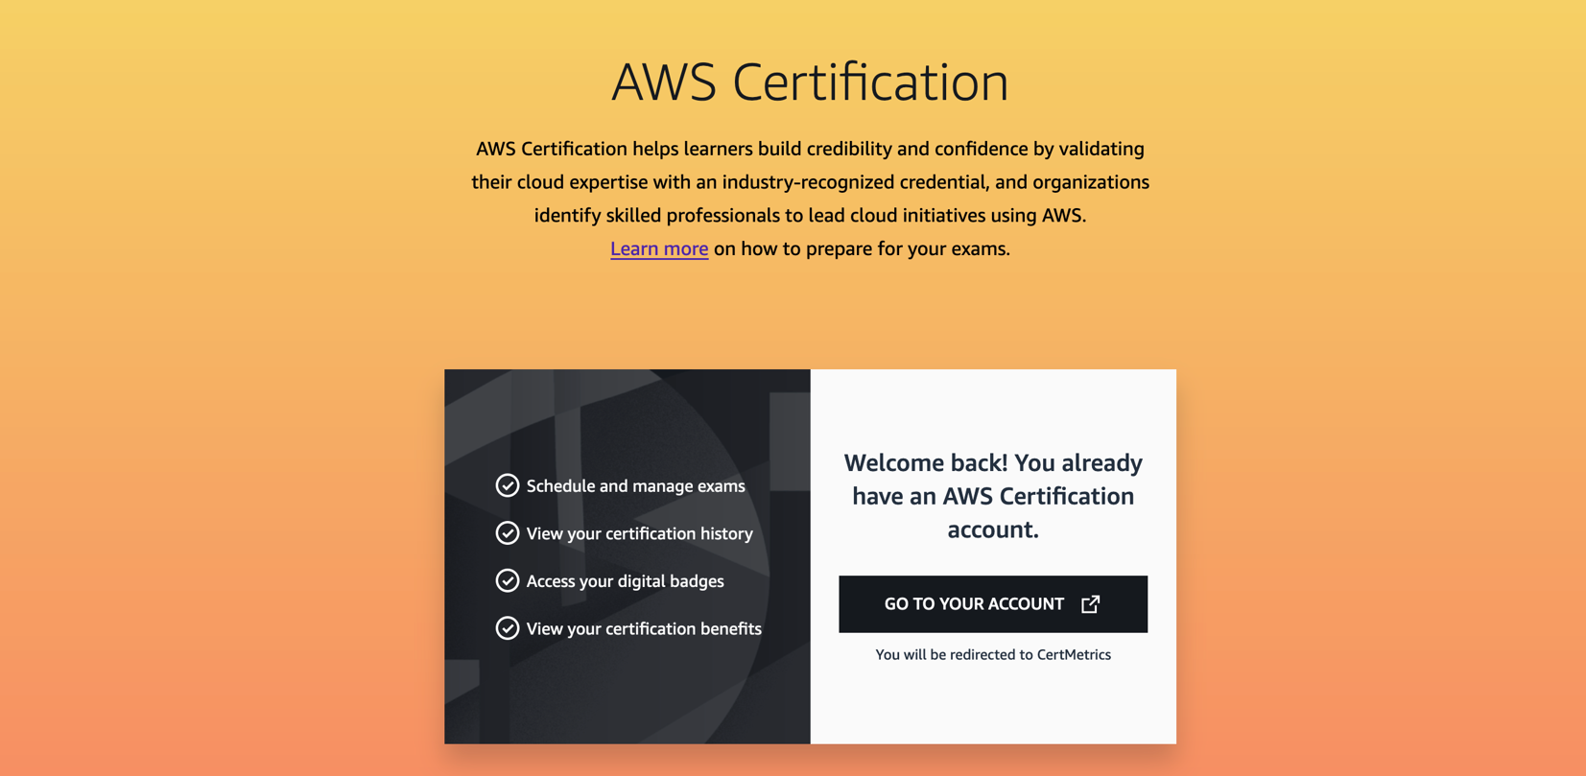

**Step 12:** Under the Home tab click on “**Manage Pearson Vue Exams**” as shown below;

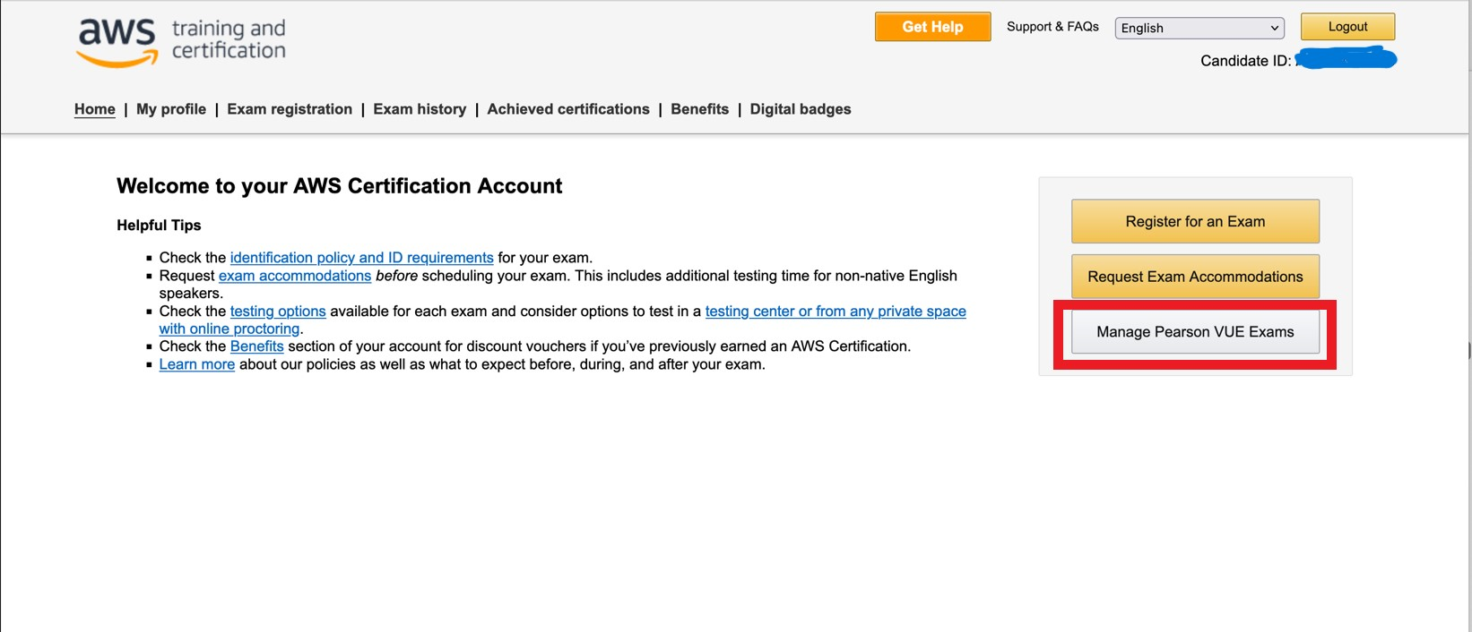

**Step 13:** Select the CLF-C02 AWS Certified Cloud Practitioner Exam as shown -

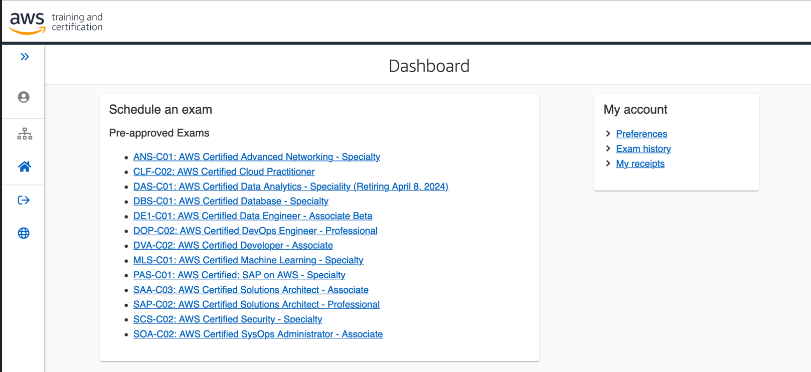

**Step 14:** You will see 3 options for taking the exam – we recommend ‘OnVue Online with On Vue’ which will allow you to take the exam from home – however you ***must*** check the compatibility of your system for taking the exam at home (see Step 15)

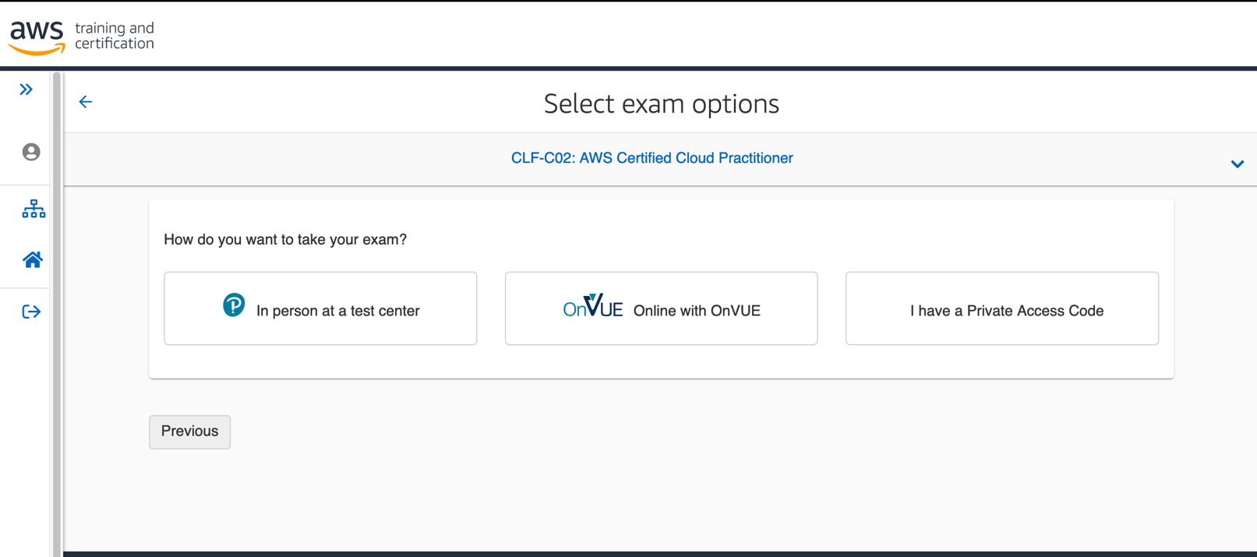

**Step 15:** Please click on Run system test **–** highlighted below

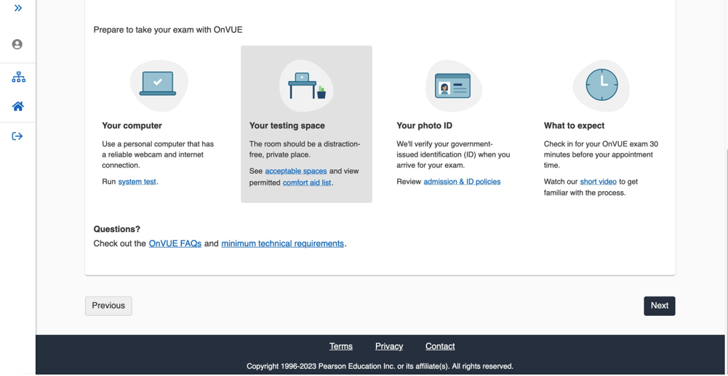

**Step 16:** At the top of the screen, you will see a tick box, which you must tick to proceed with the system check – then follow the Steps 1-3 as shown in the screenshot below (*MAC users please read notes in Step 2; ‘Download OnVue’ re* ***System Preferences***);

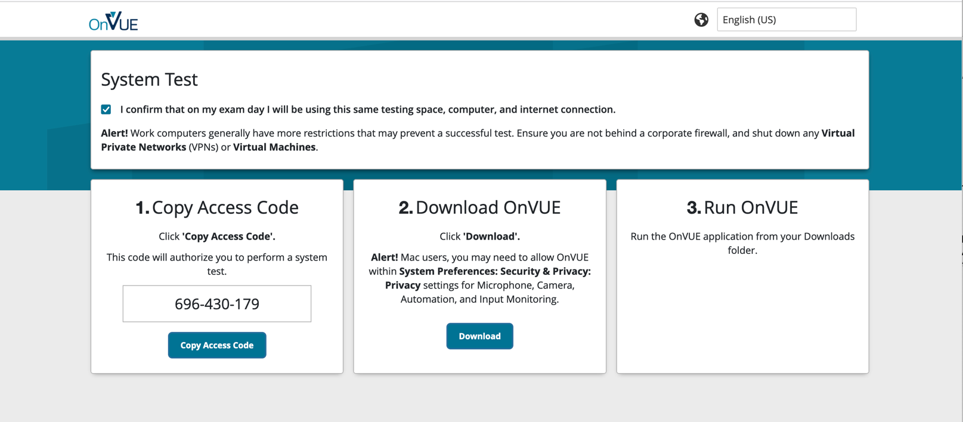

**Step 17:** Paste the code you were given on the previous screen and click Next

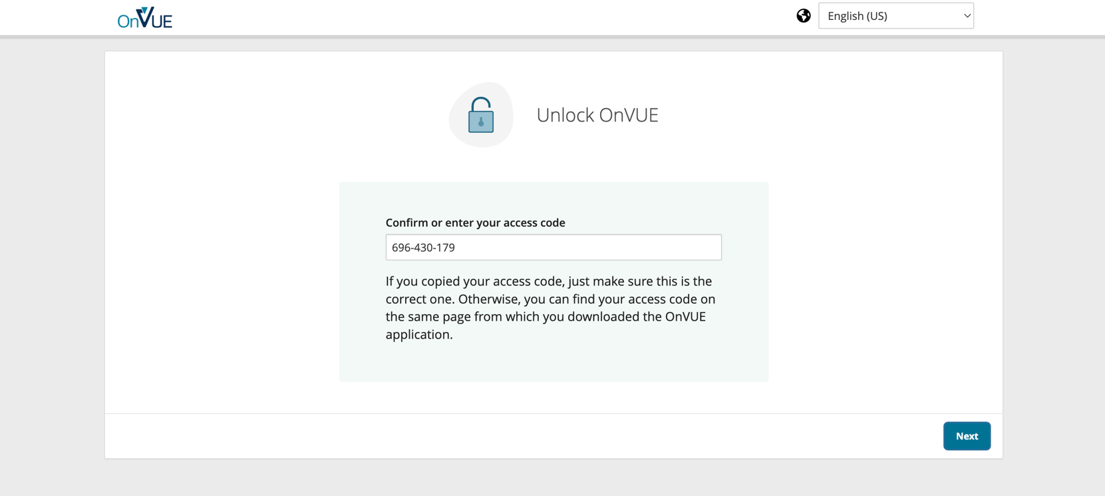

**Step 18:** Follow the prompt on screen, ensuring you complete each check in order

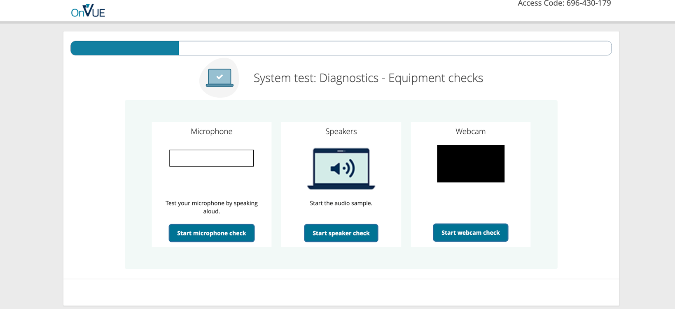

**Step 19:** As you progress through each check **Green ticks** will appear if your system meets the requirements to take the exam remotely;

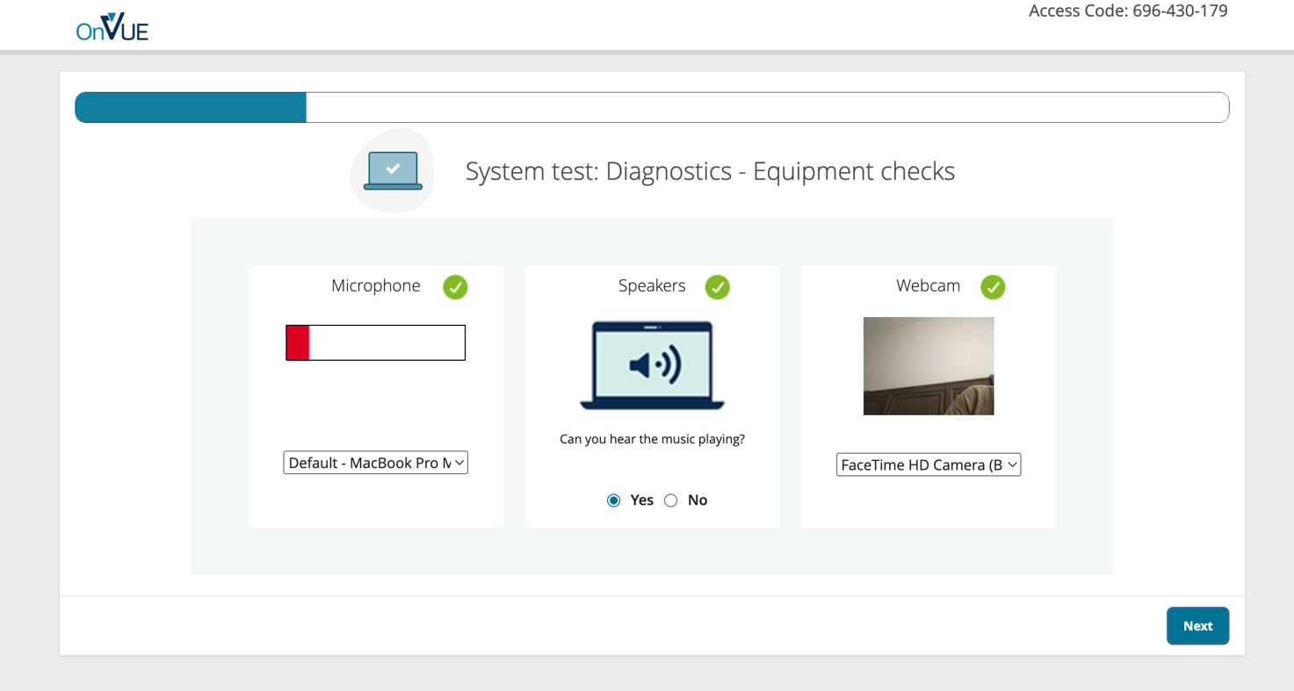

**Step 20:** You will get a confirmation your system meets the requirements shown below; however, you need to proceed with system check by completing the Exam Simulation – see step 21

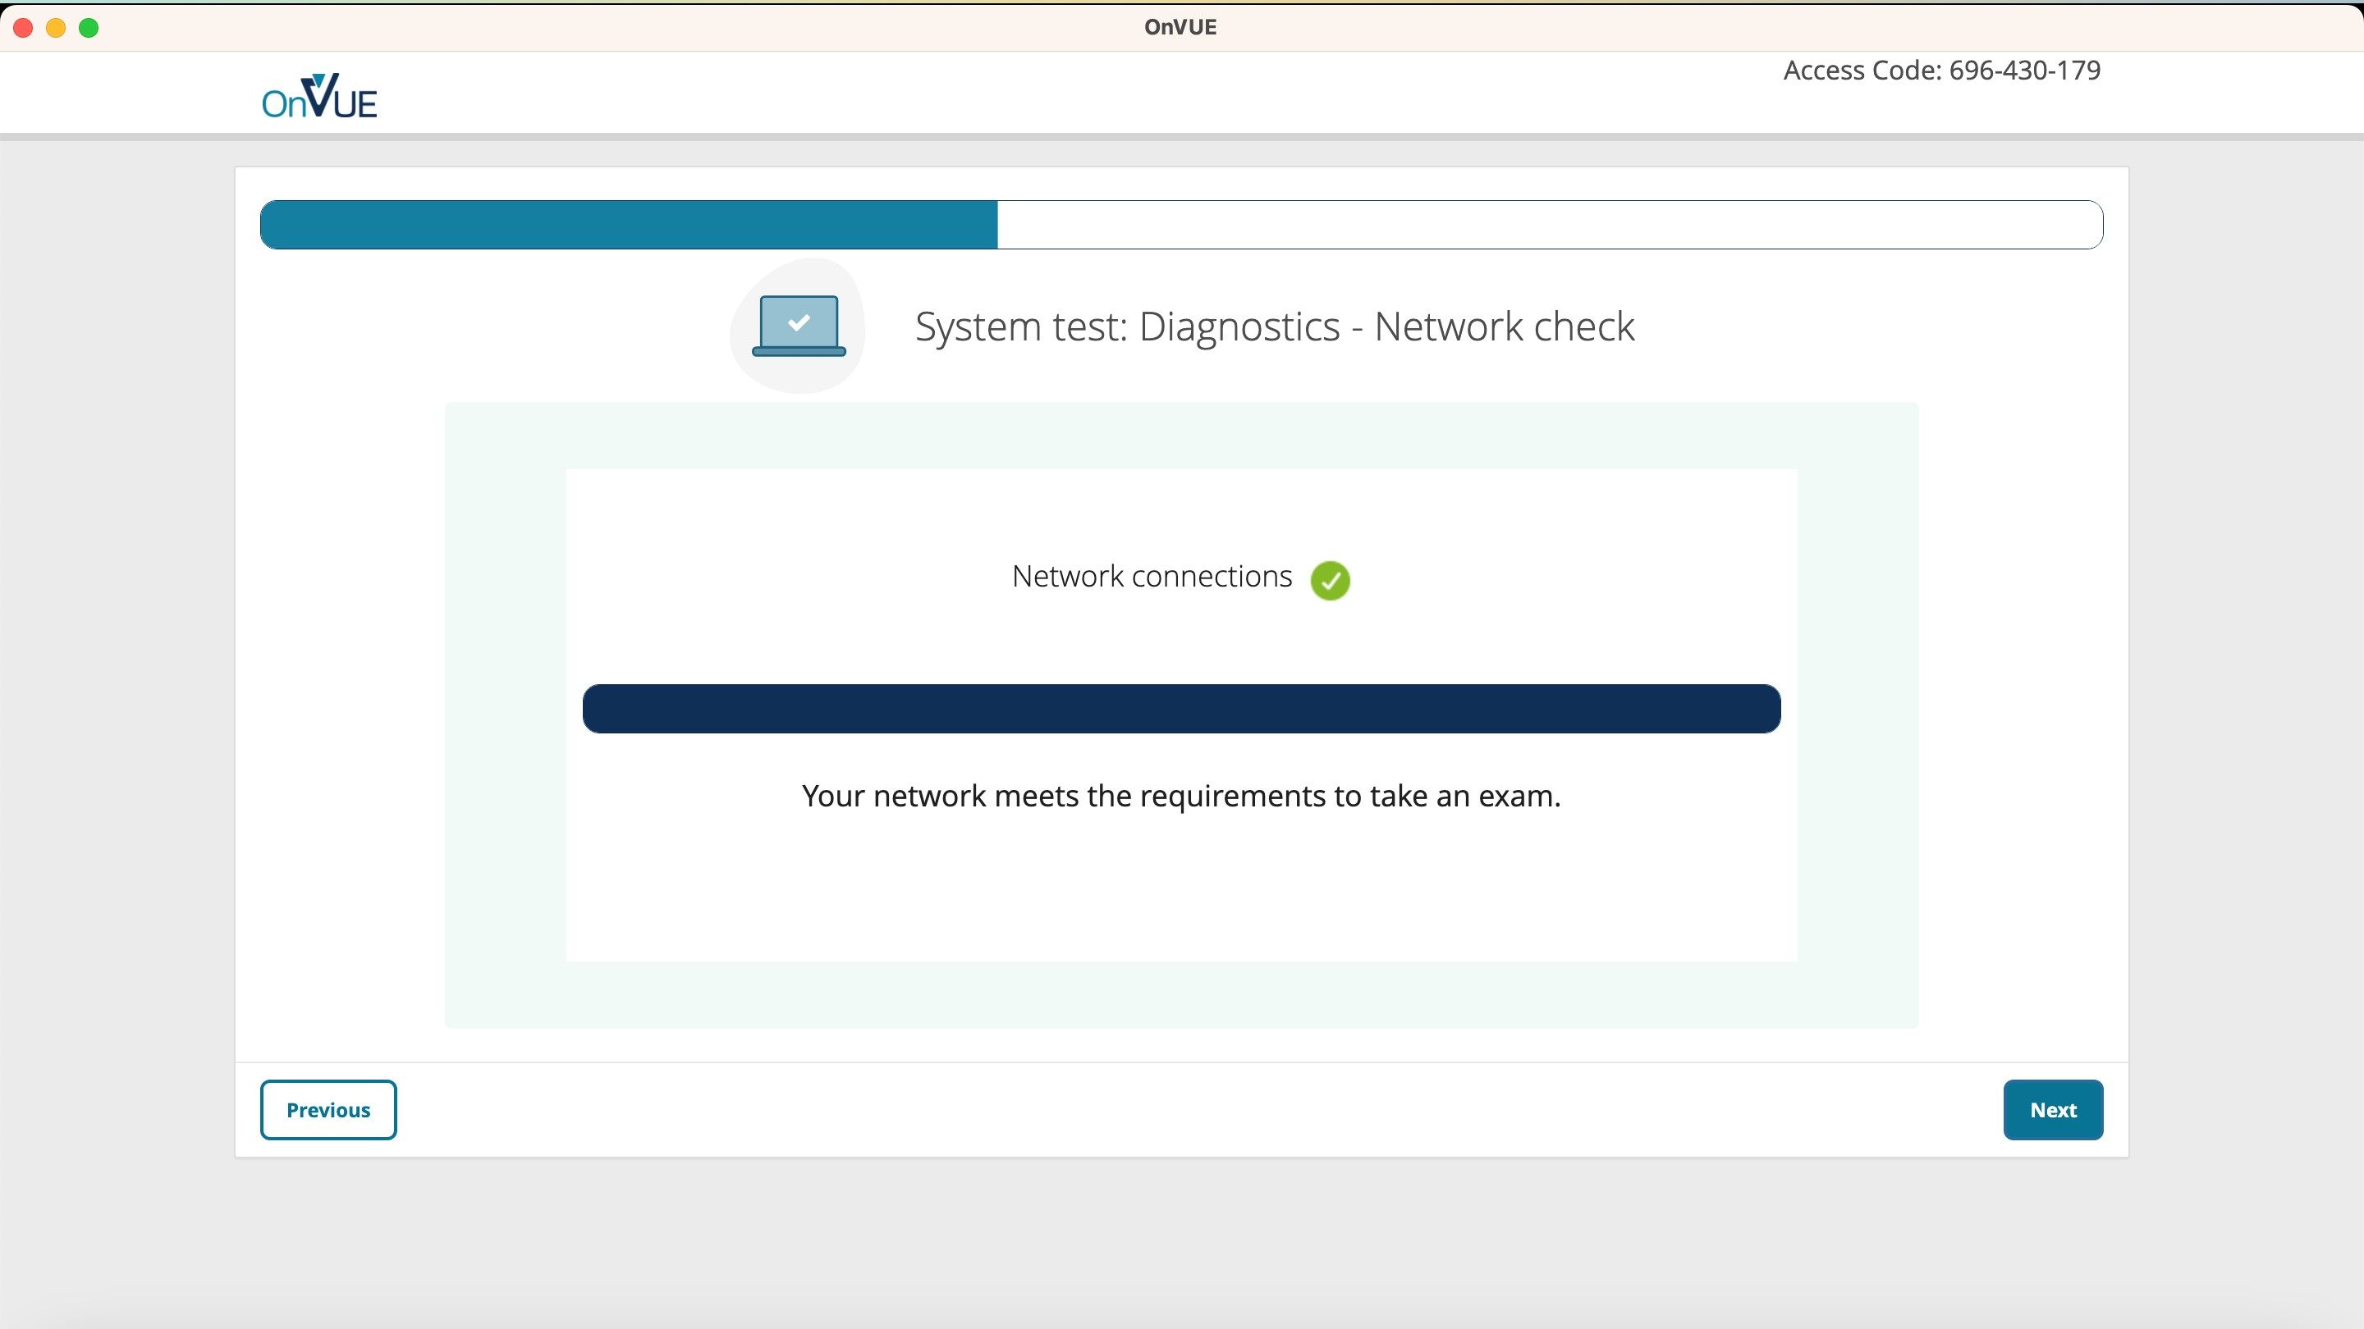

**Step 21:** To launch the exam simulation click Test

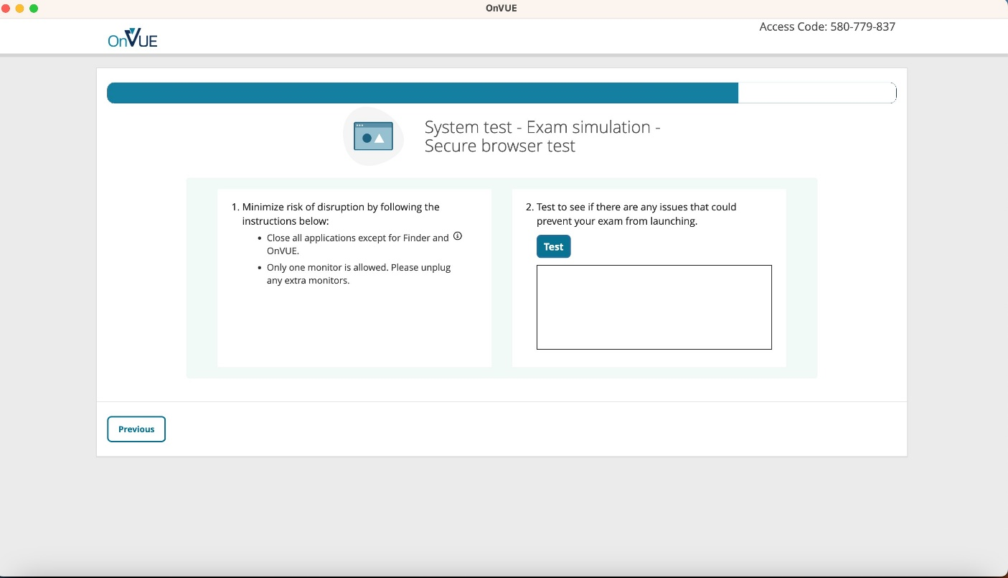

**Step 22:** Once the exam simulation concludes the following screen will appear, which if all requirements are met, will indicate – no issues detected

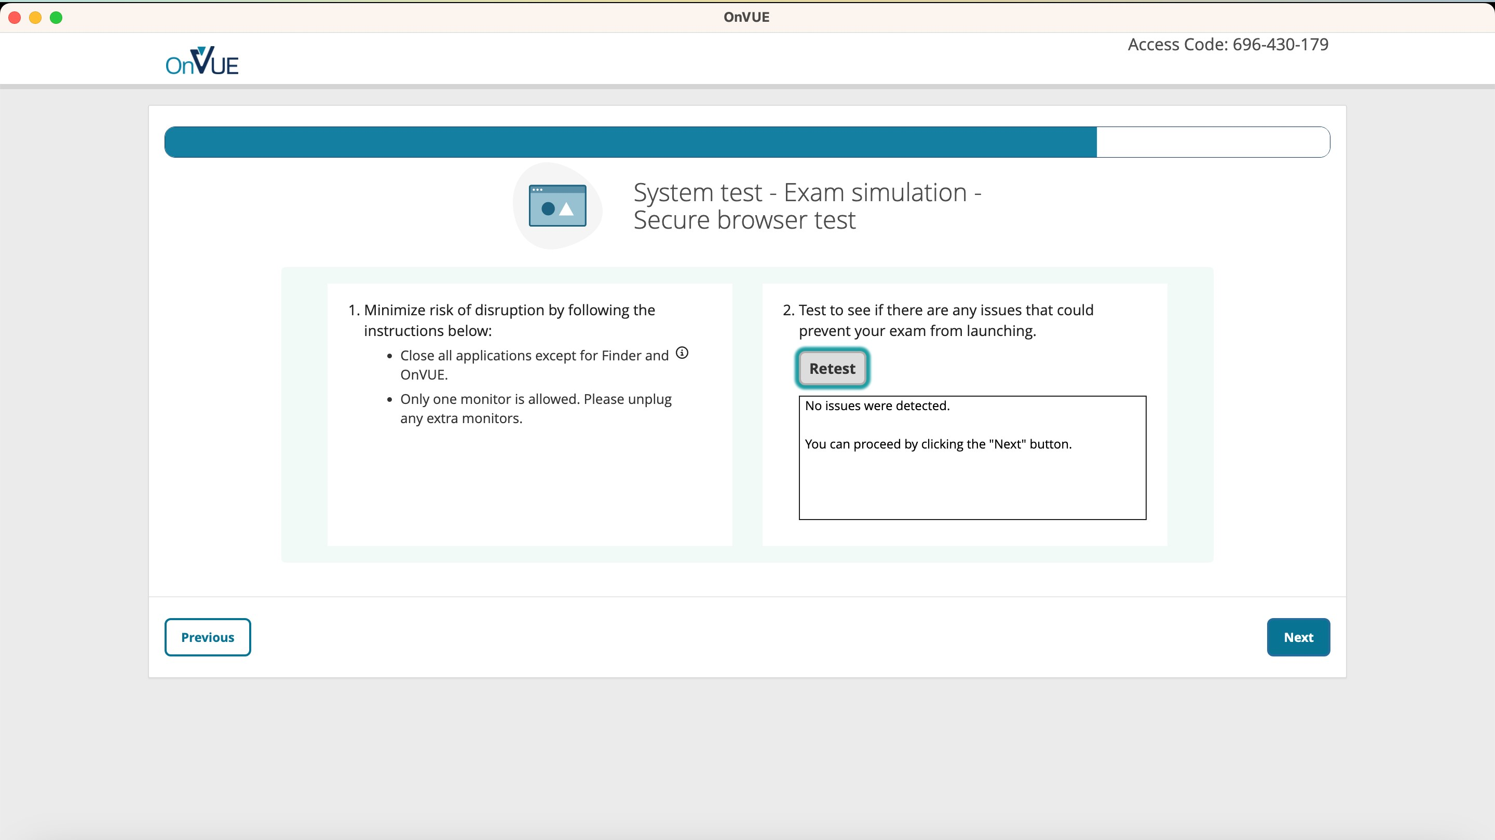

**Step 23:** You will get a confirmation of success as shown below, please follow the instructions and close the tab and continue with exam scheduling – click Close to continue scheduling your exam.

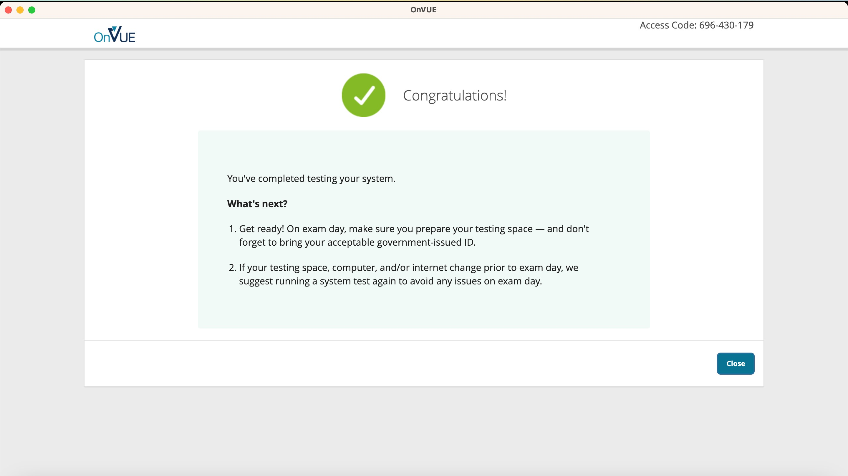

**Step 24:** Now you have tested your system, you can proceed with booking your exam by clicking Next. IMPORTANT: If your system need not meet the requirements you must choose ***‘In person at a test centre’*** so click Previous’ n the screen below to see the exam options again. 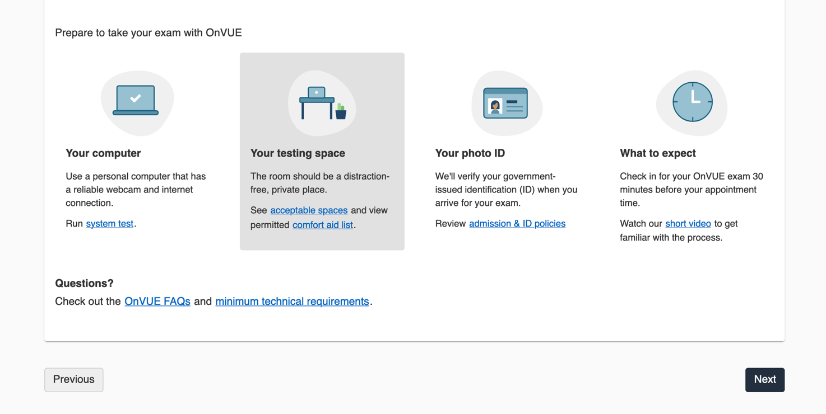

**Step 25:** Read the policies and agree by checking the checkboxes

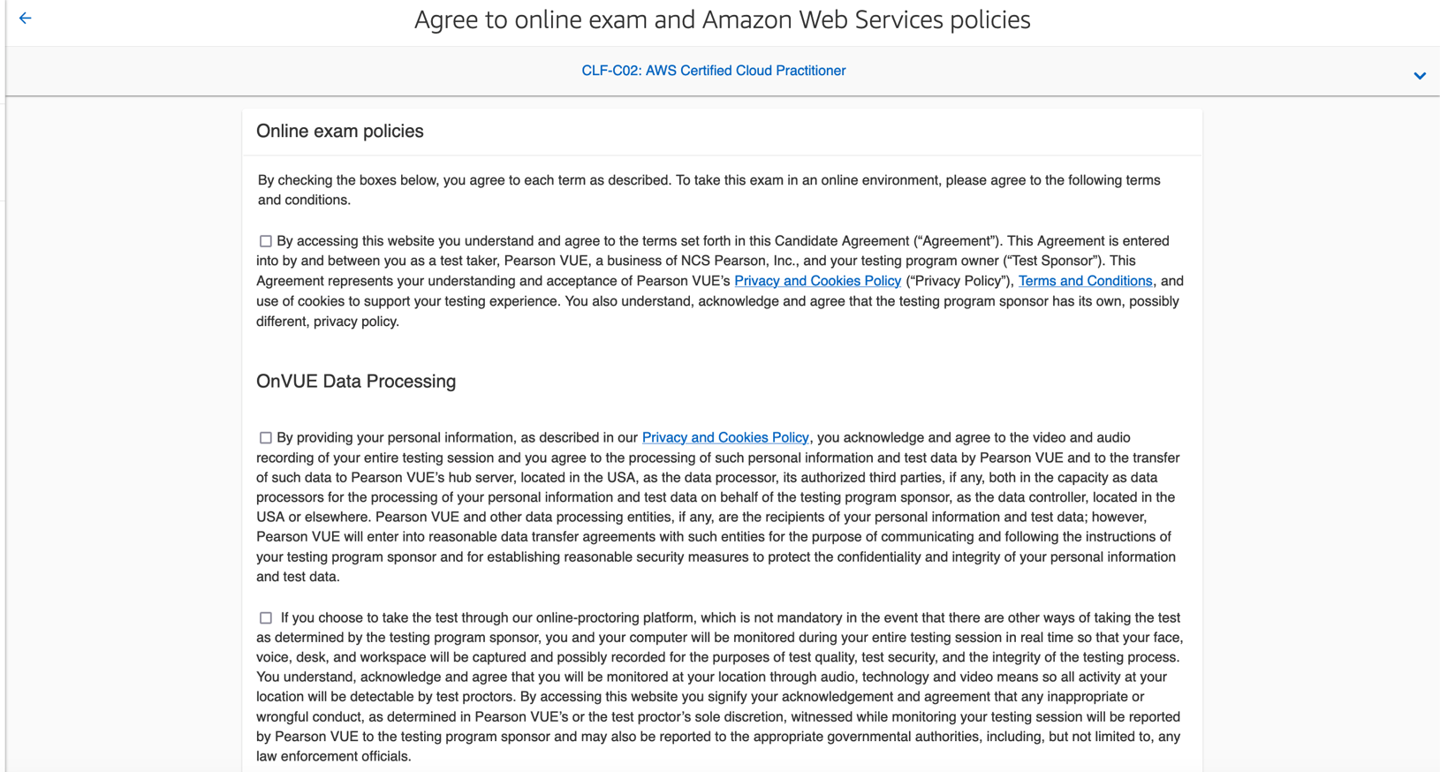

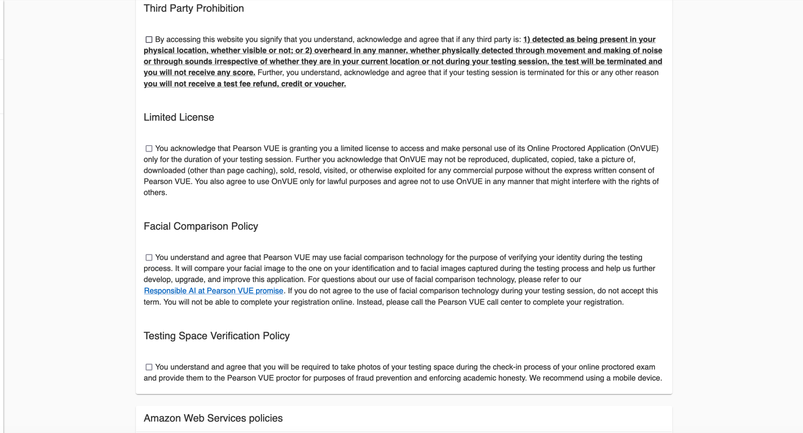

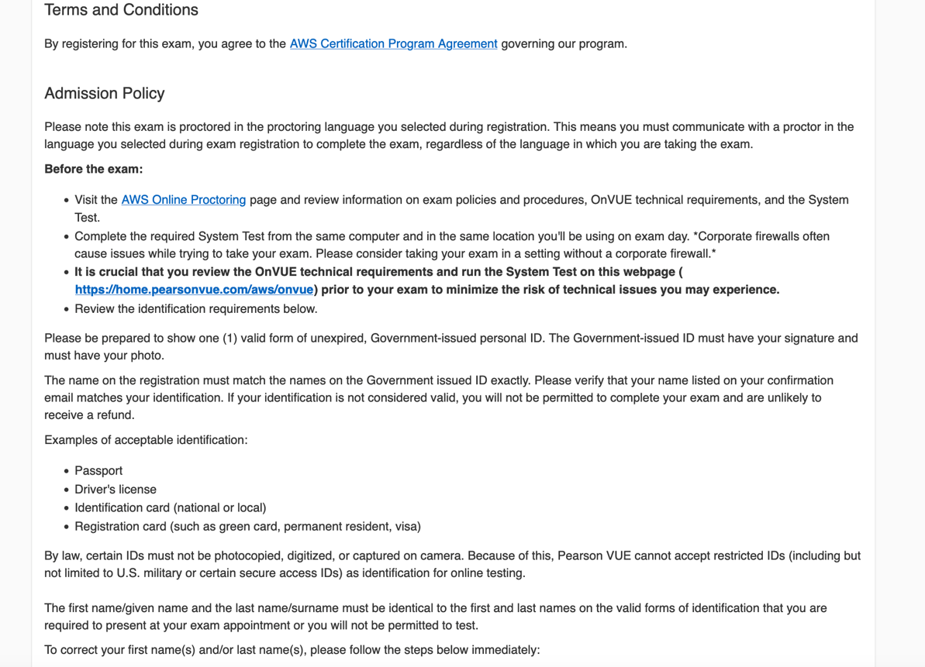

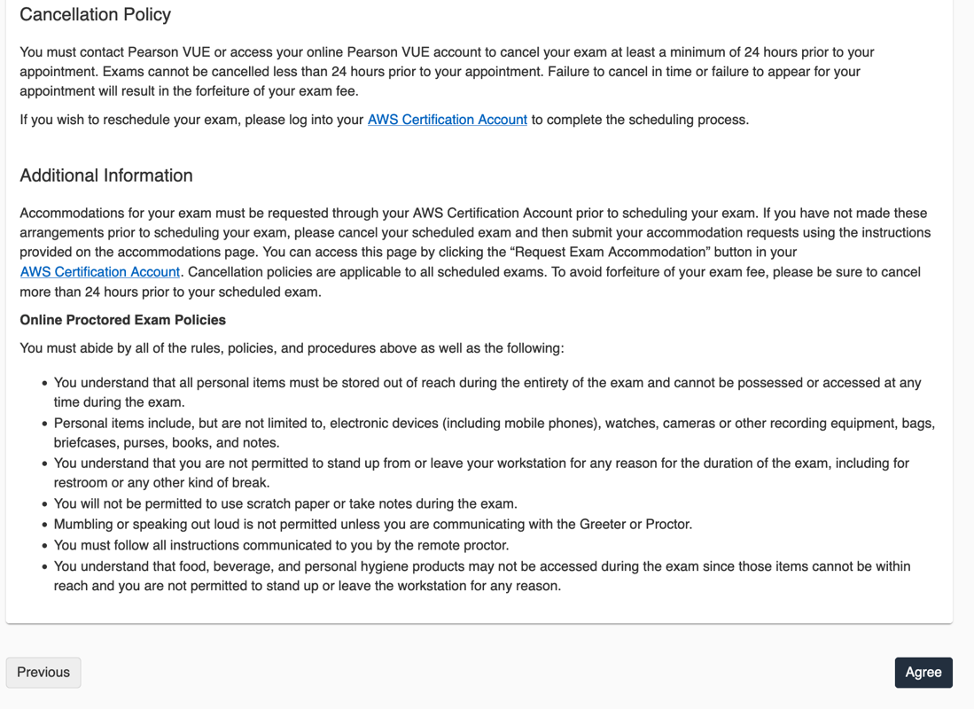

**Step 26:** Select your preferred EXAM language and click on Next

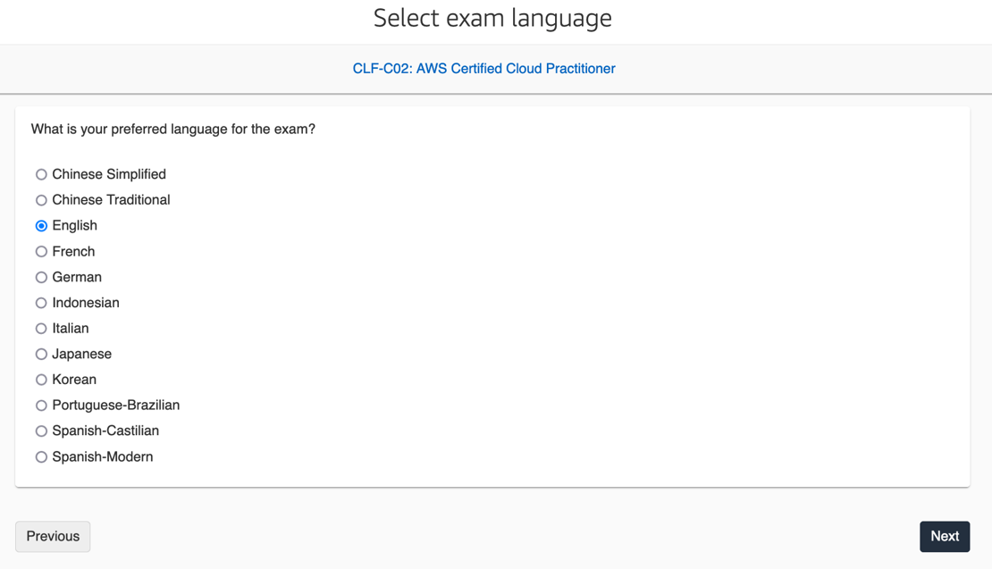

**Step 28:** Select your preferred PROCTOR/INVIGLATOR language

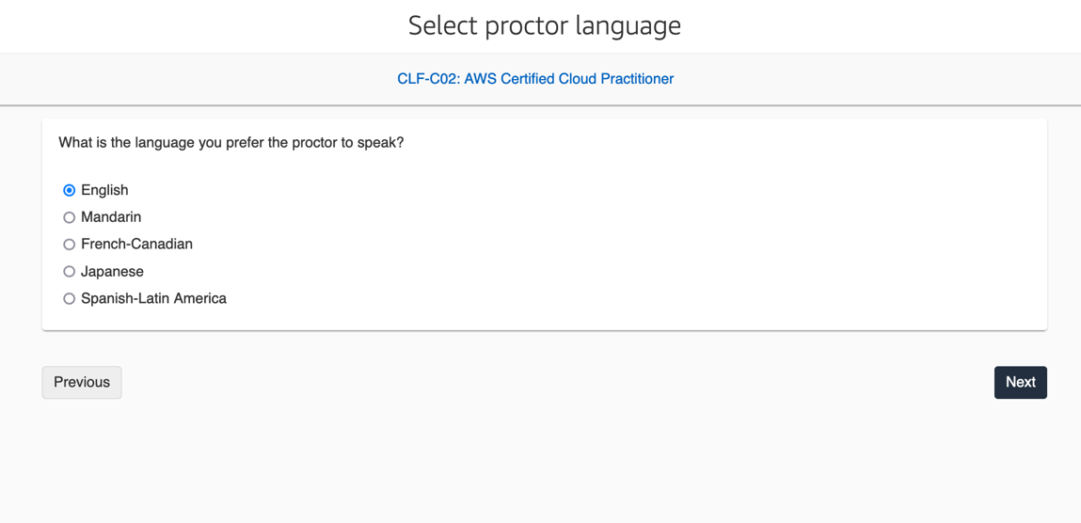

**Step 29:** Now you need to schedule your exam, firstly confirm you have chosen the right time-zone

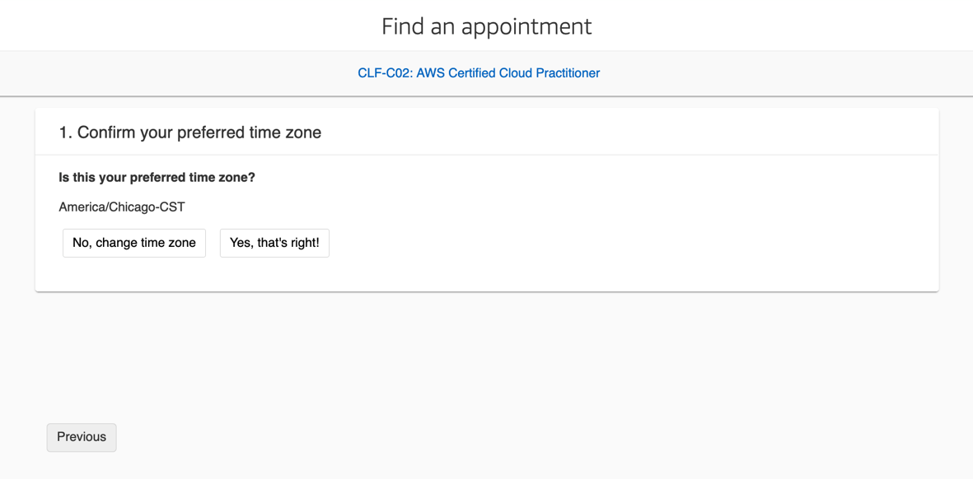

**Step 30:** Next select a preferred month and date as shown, you can change the month using the **<** and **>** buttons

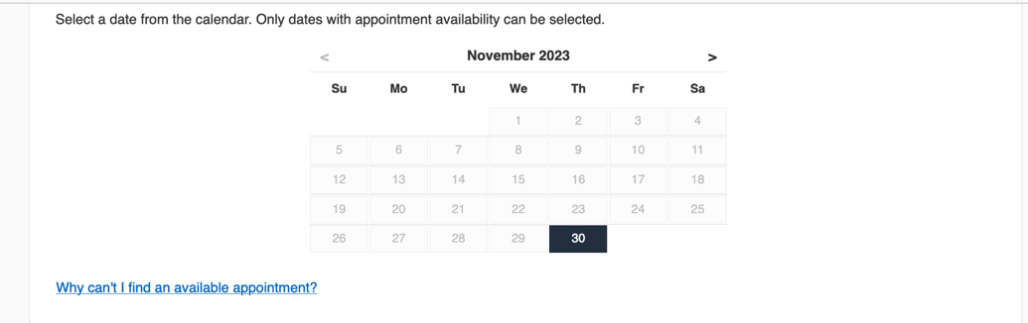

**Step 31:** Scroll down to select time slot once the date is selected, be mindful of the AM and PM times and also the time zone- if the time zone is not correct make sure to change it to your local time zone to avoid confusion.

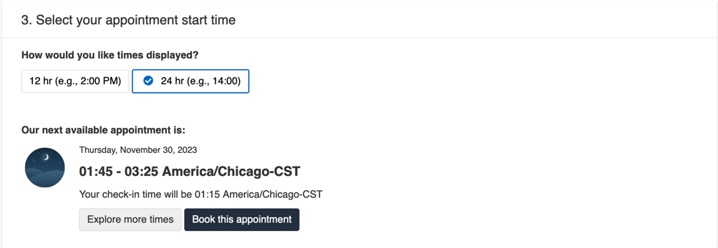

**Step 32:** Once Date and time are selected you will see Estimated Total Due as USD $100. Make sure the Exam name, Appointment details are correct – highlighted below. Once everything is verified, click on “Proceed to Checkout”

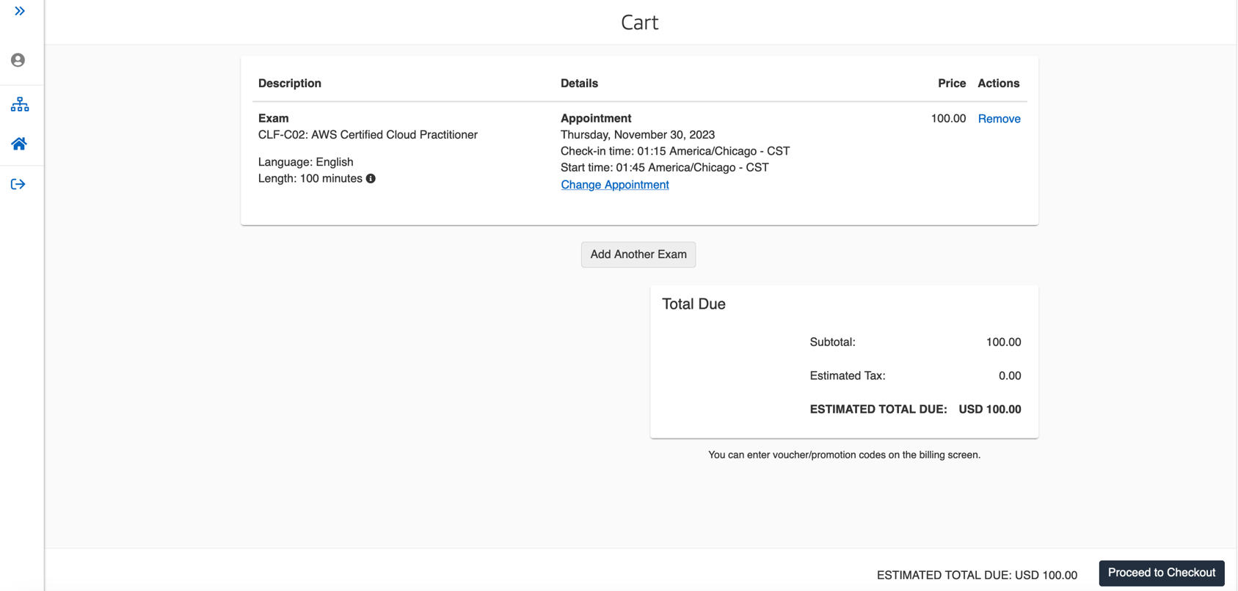

**Step 33:** Once on the screen for Enter Payment and billing click on the “Add Voucher or Promo Code” for the Voucher/promotion code cell to appear.

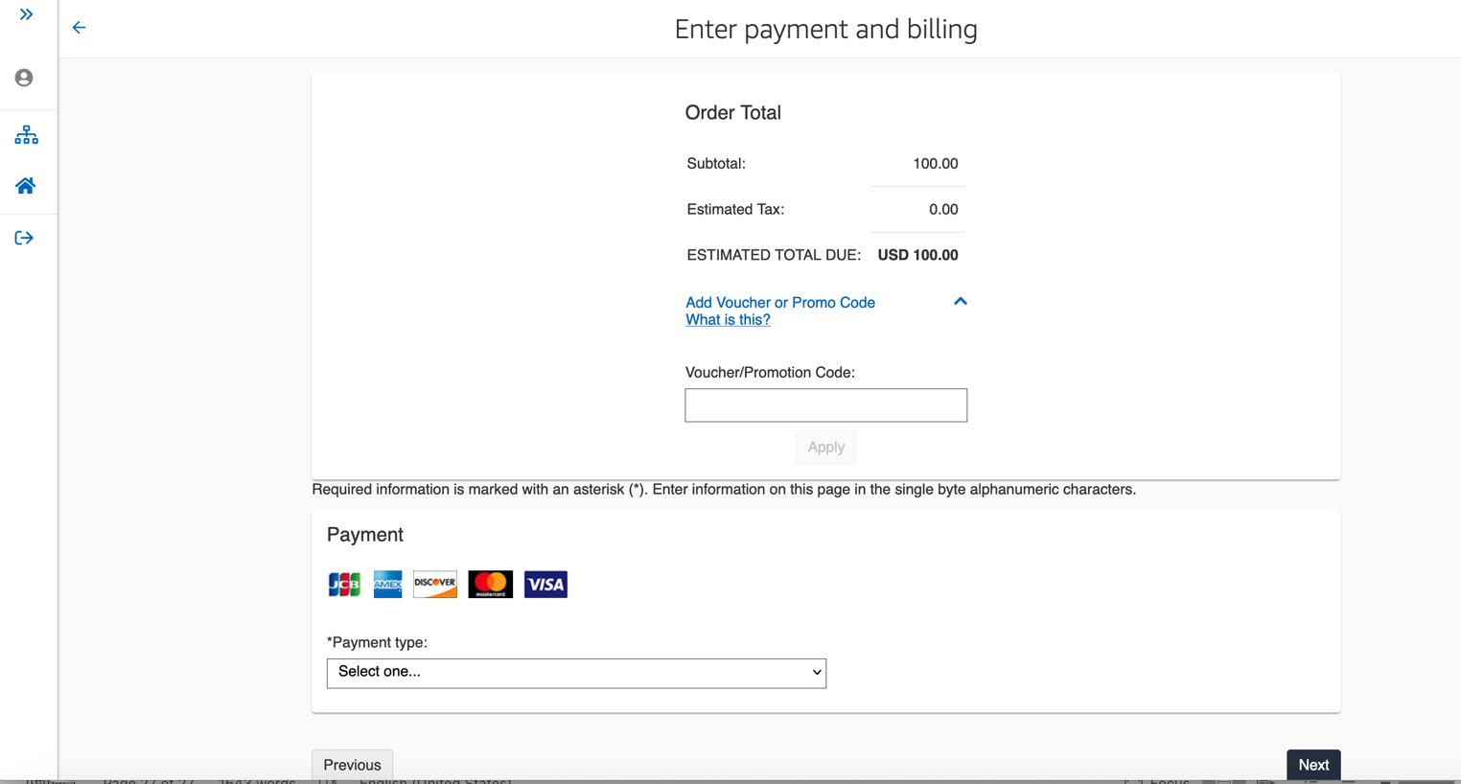

**Step 34:** Enter your voucher code provided by your instructor and AWS and Hit the “Apply” button as shown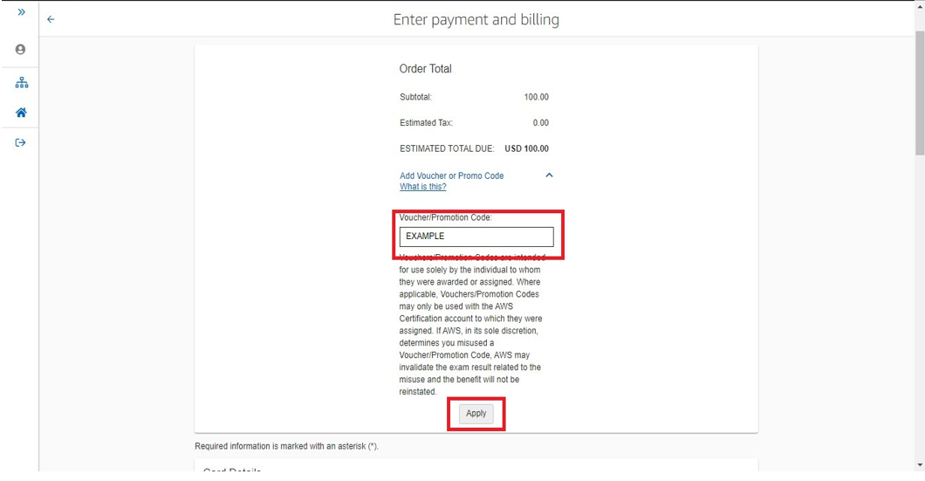

**Step 35:** You will notice the amount due change to zero, this means that your voucher is accepted.

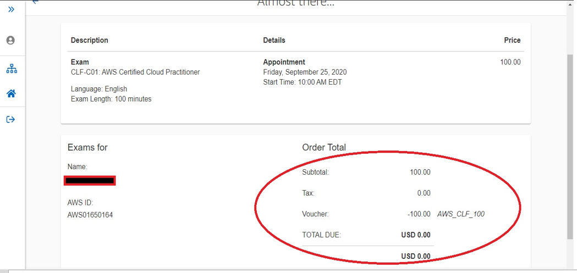

**Step 37:** Congratulations! You are booked for the exam, you will receive a confirmation email detailing your exam booking.

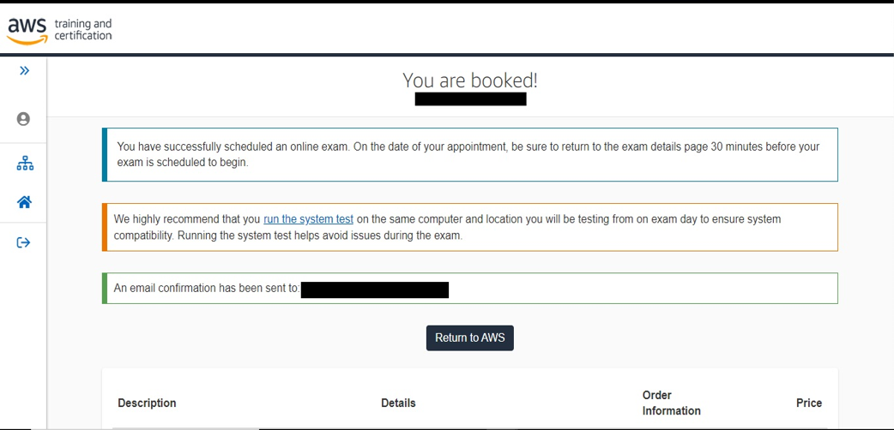

Additional Useful Information:

You may be required to complete some information regarding demographics as you book the Exam, screenshots of which are below provided for your awareness:

**Enter your profile information**

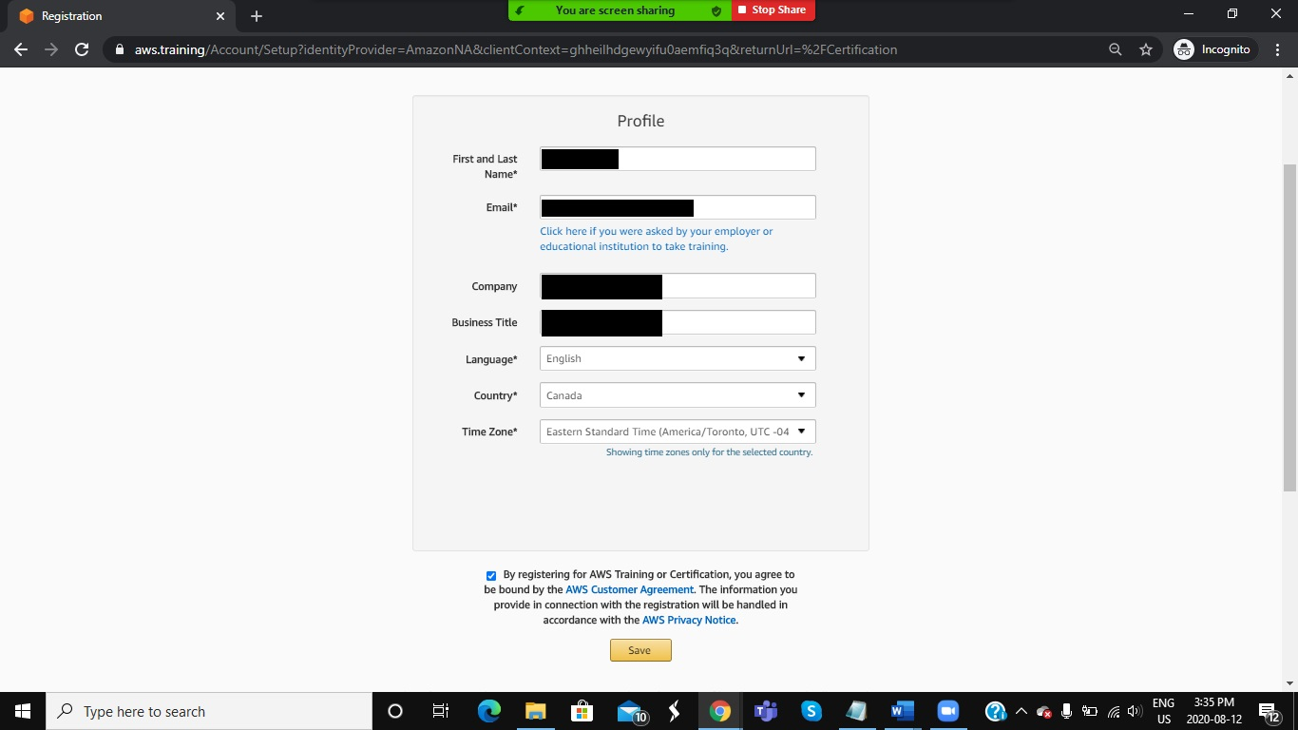

**Select the relevant options as shown**

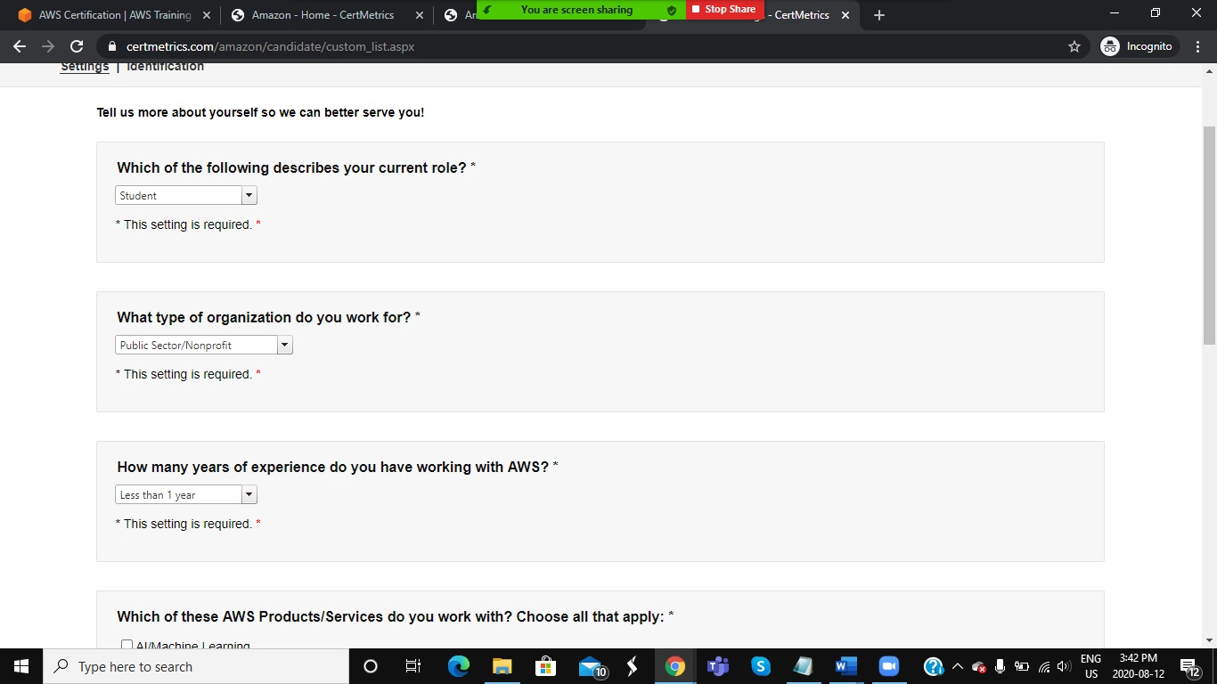

**Select relevant services as shown**

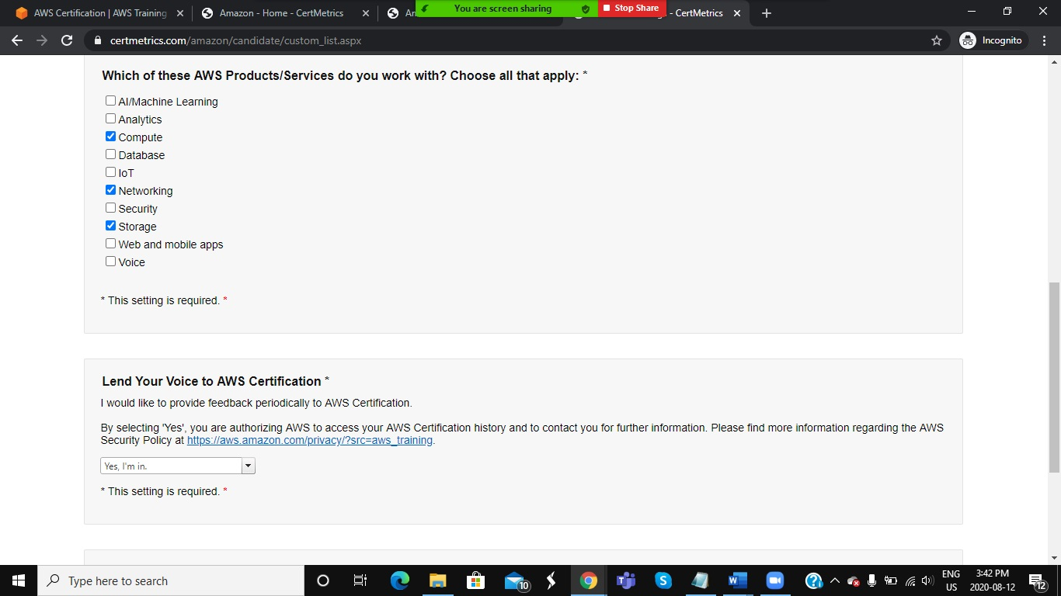

**Update and confirm your information**

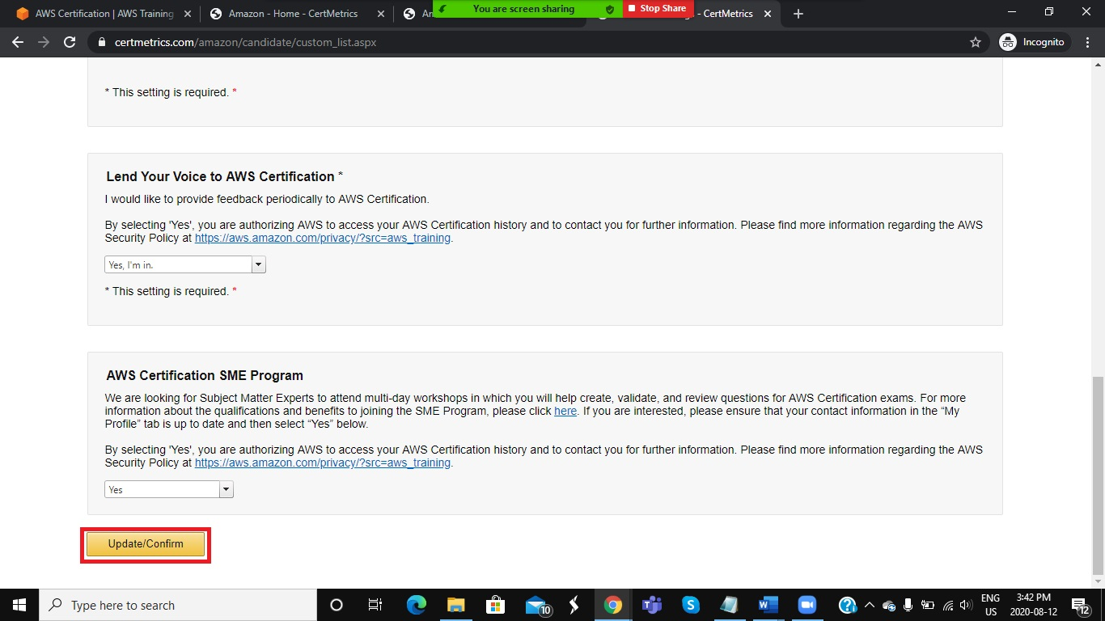

# Exam Scheduling FAQs

**Can a collaborating organization representative book the exams on behalf of the learners?**

No, learners must create an AWS certification account, ensuring they request any additional time (if applicable), this will remain linked to their account for future exams and it is once logged into their certification account they can book the exam. Therefore, the collaborating organization is not able to manage this process on their behalf.

**Do we need 6 weeks lead-time for booking exams in the same way we would for physical/in-centre exam bookings**

Availability is greater through remote proctoring so you can book an exam for the following day in some cases. **However** if you have a specific date or time you would like to take the exam I would recommend booking the exam as soon as you receive the code, don’t leave it to chance thinking you can book with only 1 days’ notice.

**Can we ensure the learners take their exam all at the same time but in their own environments?**

This is based solely on availability. Learners have to book their exam themselves, this can’t be managed on their behalf, therefore it depends if the learners all see the same availability when they log in to book their exam.

**Is it possible to book more time if English is not the first language of the learner?**

Yes, learners are able to book 30 additional minutes for the exam if English is not their first language. See Step 2 above.